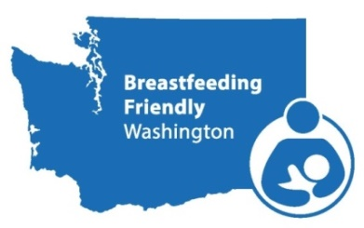
August 17, 2020
12-1:30 pm

Agenda

Meeting Objectives: At the end of the meeting, attendees will have learned:
- The rights of pregnant and breastfeeding employees in the state of WA
- The accommodations that employers are required to provided
- The work of the Attorney General’s Office of enforcing these rights

Time | Topic | Lead
12:00-12:10 | Welcome & Introductions | Yasmina Aknin - Clark County Public Health
12:10-12:40 | Healthy Starts Act Presentation | Alma Poletti  Ashley McDowell
12:40-1:00 | Q & A | All
1:00-1:15 | 2nd Annual Breastfeeding Conference  Save the Date! | Tricia Pace
1:15-1:25 | Equity Diversity Inclusion | Yasmina Aknin
1:25-1:30 | Wrap up | Yasmina Aknin
For other formats, contact the Clark County ADA Office
Voice 564.397.2322 / Relay 711 or 800.833.6388 / Email ADA@clark.wa.gov

