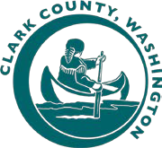
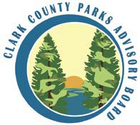
Clark County Parks Advisory Board
Meeting Agenda
Tuesday, October 12, 2021, 4:00 – 6:00 PM

PAB Members:  Kelsey Potter (Chair)  Jay Chester (Vice-Chair)  Stacy Kysar (Secretary) Barbara Anderson  John Spencer Dave Weston  Felix Ruhiri  School District Liaisons:  Cale Piland (Evergreen)  Nicole Daltoso (Vancouver)  Parks Foundation:  Dellan Redjou  Next Meeting:  November 9th 2021WebEx  **Motion Needed | - CALL TO ORDER  - ADMINISTRATIVE ACTIONS  - Meeting structure guidelines for WebEx  - Roll call / guest introductions  - Review / adopt September 14th 2021 meeting minutes **  - Reminder to submit volunteer hours  - PUBLIC COMMENT  Due to the current public health situation, the public is encouraged to participate in the following ways:  - By phone: 408-418-9388 and enter access code: 2485 677 6287  - Submit public comments to: pab@clark.wa.gov  - MANAGERS REPORT  - Rocky Houston, Introduction  - Departmental Updates & Goals  - UNFINISHED BUSINESS  - Upcoming Board Vacancies  - PAB Meeting Logistics  - PROS Plan - Review  - NEW BUSINESS  - Salmon Safe Initiative – Clean Water Commission  - MPD Budget Projections – Chad  - Future Nominations  - ROUNDTABLE DISCUSSION (PAB Members)  - ADJOURN | 4:00 PM
 |  | 10 MIN
 |  | 5 MIN
 |  | 20 MIN
25 MIN

50 MIN
 |  | 5 MIN
 |  | 5 MIN
 |  | 6:00 PM

Parks Advisory Board meetings get recorded and the audio gets posted on the Clark County Parks website.

