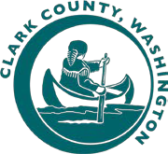
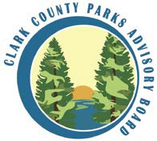
Clark County Parks Advisory Board
Meeting Agenda
Tuesday, February 8th, 2022, 4:00 – 5:00 PM

PAB Members:  Vacant (Chair)  Vacant (Vice-Chair)  Stacy Kysar (Secretary)  John Spencer  Felix Ruhiri  Donald Meeks  James Kautz  School District Liaisons:  Cale Piland (Evergreen)  Nicole Daltoso (Vancouver)  Parks Foundation:  Dellan Redjou  Next Meeting:  March 8th, 2022 Microsoft TEAMS  **Motion Needed | - CALL TO ORDER  - ADMINISTRATIVE ACTIONS  - Meeting structure guidelines for Teams  - Roll call / guest introductions  - Approve January 11th, 2022 meeting minutes**  - PUBLIC COMMENT  Due to the current public health situation, the public is encouraged to participate in the following ways:  - By phone: 213-262-7043 and enter access code: 422 063 027#  - Submit public comments to: pab@clark.wa.gov  - MANAGERS REPORT  - Departmental Updates & Goals  - UNFINISHED BUSINESS  - NEW BUSINESS  - New PAB Member Introduction  - Election of Officers**  - ROUNDTABLE DISCUSSION (PAB Members)  - ADJOURN | 4:00 PM
 |  | 10 MIN
 |  | 5 MIN
 |  | 10 MIN
25 Min

5 MIN
 |  | 5 MIN
 |  | 5:00 PM

Parks Advisory Board meetings get recorded and the audio gets posted on the Clark County Parks website.

