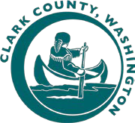
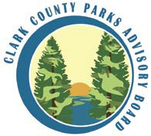
Clark County Parks Advisory Board
Agenda Item

Date: | 4/12/2022
Agenda Item: | Shelter Reservation Season Extension Pilot
 |  |  | Action Item | X
 |  |  | Informational Item
Overview:

Picnic shelters at select regional and community parks are currently reservable between May 1 and September 30. This annual reservation period was established when City of Vancouver and Clark County parks were managed together. Anecdotal information from staff indicates that the shelters are widely used throughout April and into late October. To meet the recreational demand for these facilities and their amenities we are looking to pilot the extension of the reservable period.

After review with staff and PAB, we are looking to pilot shelters being reservable from April 1 to October 31. A pilot of allowing reservations to occur 11 months in advance of the reservation will be piloted as well for 2023. Vancouver Lake shelters follow a different schedule, typically opened for Memorial Day weekend, due to site conditions.

In the 4th quarter of 2023, staff will report back on the pilot program and make a recommendation to PAB on next steps.

Prior Action by PAB: |  | None
Action Requested: |  | Recommend the Pilot Program for shelter reservations and reservation season be implemented in 2023.
Attachment: |  | None
Prepared By: |  | Rocky Houston

