Board Members: Donald Meeks, Teresa Meyer, Jim Kautz, John Spencer, Stacy Kysar*, Felix Ruhiri
Clark County Staff: Rocky Houston, Jessica Cretsinger
Ex-Officio Members : School District Liaisons: Cale Piland (Evergreen)*,
Nicole Daltoso (Vancouver)*
Parks Foundation: Dellan Redjou*
Guests: Gordon Thomas
* Not Present

Call to Order:
Chair – John Spencer called the meeting to order at 4:00 PM

Minutes:
February 8, 2022 minutes adoption were tabled for April 12, 2022 meeting

Public Comments:
Gordon Thomas – interested in pickleball courts at Pacific Community Park

Managers’ Report
Please see attached pdf of items presented.

Unfinished Business
No items

New Business
Agenda Item: | Maintenance Management Planning Overview
 |  | Action Item
 |  | Informational Item | X
Overview:

The 2022 PROS Plan process identified what the Clark County Parks operations do in a typical year (hours) and the cost per acre. However, the division does not have a clear understanding of what we should have been doing and how our maintenance activities compare to this level of service and/or maintenance planning. In addition, a review of National Recreation Parks Association (NRPA) data shows that Clark County Parks lies outside of the median on several key measurements. This includes being well above similar park systems in total number of parks, miles of trail managed, acres of parkland and residents per park. We were well below similar park systems in staff per populations, operating budget per acre of parkland and capital budget.

The development of a maintenance management plan (MMP) will assist the division in meeting Goal #8: Operations. An MMP provides an assessment by property of the hours required to meet the level of service for that property. It is based off an assigned level of service (frequency of tasks performed), the assets at the property and an assigned time allocation per task unit. An MMP allows the division to look forward and plan our resources accordingly. It also allows us to make operational decisions based off data and present policy decisions based off that data.

The division will be working this calendar year to develop and finalize an MMP. When the MMP is completed, we will be able to assess our staffing needs, evaluate our current unit’s workload fairly and begin to plan to address any deficiencies that are identified.

The division has begun the level of service determination for each property and the inventory of assets. The next step will be evaluating the task frequency by level of service and identifying the time allocation per task unit. The Division has sent (2) staff to the Pacific Northwest Resource Management School to learn more on the philosophies and techniques of resource management. The program also teaches participants on how to communicate stewardship needs of developed land, facilities, and natural resources.

The division will report its findings and recommendations when the MMP is completed.

Agenda Item: | Shelter Reservation Season Extension Pilot
 |  | Action Item
 |  | Informational Item | X
Overview:

Picnic shelters at select regional and community parks are currently reservable between Memorial Day weekend and September 30. This annual reservation period was established when City of Vancouver and Clark County parks were managed together. Anecdotal information from staff indicates that the shelters are widely used throughout May and into late October. To meet the recreational demand for these facilities and their amenities we are looking to pilot the extension of the reservable period.

Initial review by staff identified that starting the reservation period on May 1st and ending on October 30th would address a majority of shelter use. This period also aligns with seasonal staffing to assist with managing these facilities.

Expanding the shelter reservation period will:
- Improve patron access to reserved shelters to meet recreational demand.
- Allow staff to more effectively manage special events and park capacity constraints that exist before/after the current reservation period.
- Enable maintenance and operations staff to accommodate shelter use into work plans.
- Facilitate more efficient winterization of parks facilities, reducing costs and maintenance needs during the winter.

The pilot program is planned to begin in 2023. This allows the division adequate time to update reservation procedures and systems, ensure appropriate staffing levels for the extended reservation period, and to communicate the changes to Clark County residents. Staff is requesting the PAB review this proposed pilot program and provide feedback. Specifically, staff would like the PAB’s review and comments regarding:
- Locations: staff are recommending the pilot program (see exhibit A)
- Should staff consider piloting other reservation program changes, including:
  - Advance reservation period: shelters are currently reservable 12 months in advance; is this equitable for all residents?
  - Reservation options: some sites allow reservation of half of a shelter. Should this be considered at other locations? Should half shelter reservations be available at any locations?
  - Reservation period: is the proposed reservable period (May 1 through Oct. 31) sufficient? Should some shelters be reservable all year?

The division will use the PAB’s feedback to finalize the pilot program proposal, which will be reviewed by the PAB at a later meeting.
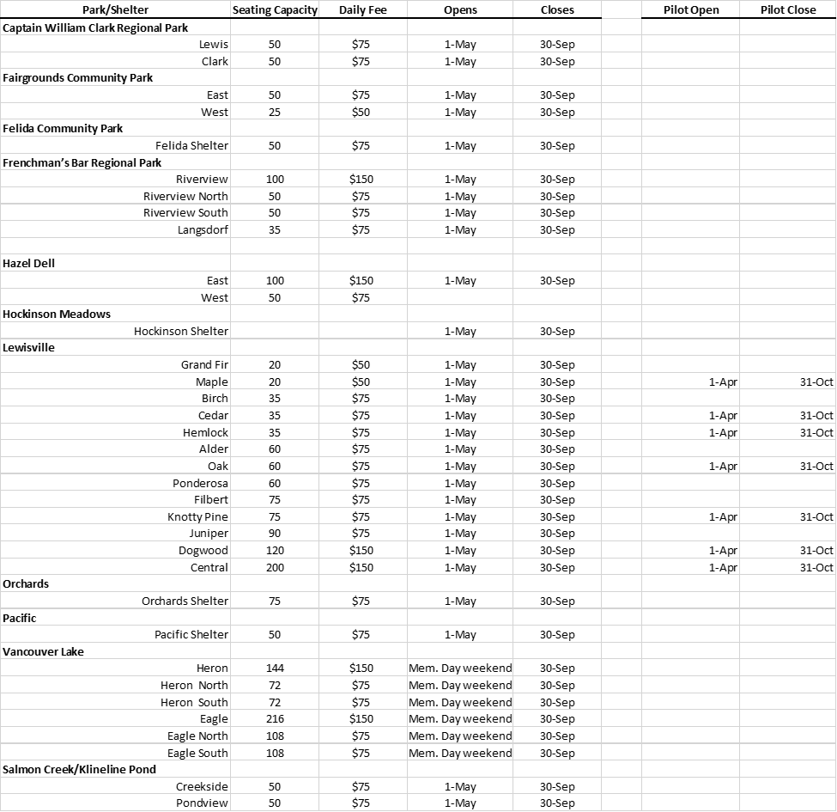

PAB discussed this pilot program and the equity issues surrounding potential reservation period changes. There was general support for the extension of the reservable period.

Roundable Discussion
Don Meeks discussed the new permit and fee system being implemented for the Historical Columbia River Highway in Oregon. USFS had implemented a permit/fee system to hike Multnomah Falls Trail previously and it has improved crowding and is managing use well.

Teresa Meyer discussed that Mt. Jefferson Trails (USFS – Oregon) has implemented a similar reservation/fee system there as well.

Adjourn

Respectfully submitted, Jessica Cretsinger

