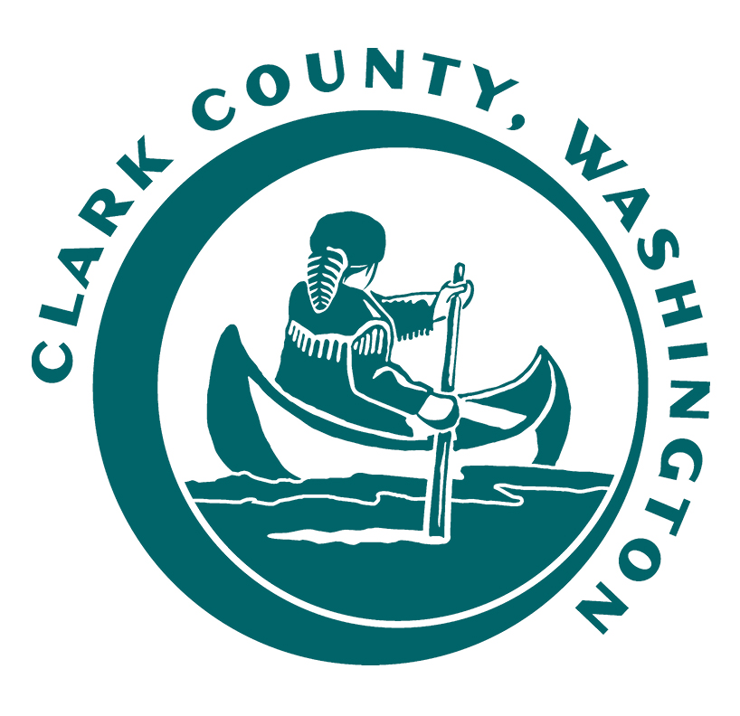
RAILROAD ADVISORY BOARD

MEETING AGENDA

Monday, June 12, 2023
4:00 PM - 5:30 PM
Hybrid Meeting
In Person - Public Service Center, 1300 Franklin St.
6th Floor – Council Training Room
Virtually - Cisco Webex Online Meeting

Meeting Call to Order | Dan Weaver, Chair
Roll Call | Dan Weaver, Chair
Approval of Previous Meeting Minutes | Dan Weaver, Chair
Comments from the Chair | Dan Weaver, Chair
PVJR Activities | Nathan Bruce, PVJR
BYCX Activities | Randy Williams, BYCX
County Activities  - GCB 3592 grant update  - GCB 1249 grant update  - Railroad Bridge Management Plan update | Kevin Tyler, Clark County
Unfinished Business  - RRAB bylaws - update  - May 17 Freight Rail Dependent Use work session debrief | Dan Weaver, Chair  John Shaffer, Vice Chair  Kent Cash, member
New Business  - RRAB work session request for Freight Rail Dependent Use | Dan Weaver, Chair
Public Testimony  - Public comment received: Solar Panels on Railroad Tracks | Dan Weaver, Chair
Good of the Order | Dan Weaver, Chair
Adjournment | Dan Weaver, Chair

