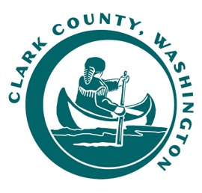

**RAILROAD ADVISORY BOARD**

**MEETING AGENDA**

***Monday, August 11, 2025***

***4:00 PM - 5:30 PM***

***Hybrid Meeting***

***In Person -*** *Public Service Center, 1300 Franklin St.*

*6th Floor – Council Training Room*

*Virtually – Microsoft Teams*

|  |  |
| --- | --- |
| Meeting Call to Order | Dan Weaver, Chair |
| Roll Call | Dan Weaver, Chair |
| Approval of Previous Meeting Minutes   * June 09, 2025, minutes | Dan Weaver, Chair |
| Comments from the Chair | Dan Weaver, Chair |
| PVJR Activities | Nathan Bruce, PVJR |
| BYCX Activities | Randy Williams, BYCX |
| County Activities   * Railroad Roadbed Rehab contract and grant update | Kevin Tyler, Clark County |
| Unfinished Business   * Railroad presentation and open house | Dan Weaver, Chair |
| New Business |  |
| Public Testimony | Dan Weaver, Chair |
| Good of the Order | Dan Weaver, Chair |
| Adjournment | Dan Weaver, Chair |