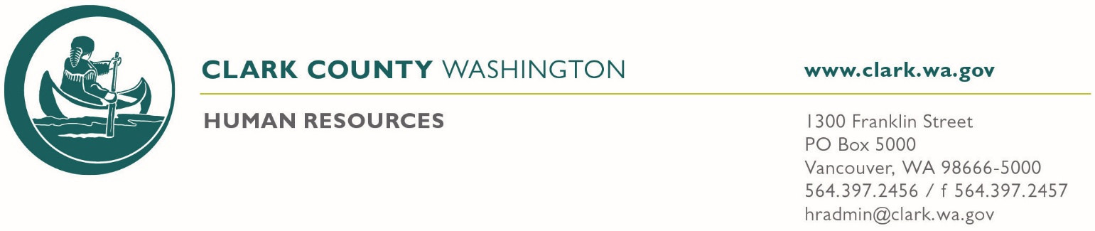
: Clark County Civil Service Commission Meeting

In Attendance

Commissioner Marla Ludolph-Heikkala (Chair)
Commissioner Crystal Kroeller (Vice Chair)
Commissioner Leah Anaya
Commissioner Garry Presthus
Commissioner Colette Draper
Senior Deputy Prosecuting Attorney Stephen Archer (Counsel to the commission)
Secretary/Chief Examiner Leslie Harrington Smith

Meeting Date: November 6, 2025 Regular Meeting
Meeting Time: 10:00 AM Special Meeting

Location: This meeting will take place IN PERSON and via Microsoft Teams.
Conf Rm. 511 Conf Rm. 523 Conf Rm. 433
CCSO Admin Classroom Conference Call
Microsoft Teams meeting LINK: Join the meeting now
(Phone Number +1 213-262-7043 Phone Conference ID: 620 136 626#)

SPECIAL SESSION:

- Commissioners to review and act on the following background investigations submitted for certification:

Adams, Elijah – Deputy Sheriff
Adams, Nathan – Deputy Sheriff
Anderson, Robert – Lateral Deputy Sheriff
Haney, Johnathan – Lateral Deputy Sheriff

- Commissioners to review and confirm the following background investigations for removal:
Chaparro, Rosi – Sheriff’s Support Specialist II
Drefchinski, Victoria – Sheriff’s Support Specialist II

Next regular meeting is scheduled for Thursday November 20, 2025, at 3PM
Commissioners may confirm attendance:
Commissioner Marla Ludolph-Heikkala
Commissioner Crystal Kroeller
Commissioner Leah Anaya
Commissioner Garry Presthus
Commissioner Colette Draper

