Workshop Script
STASHA Peer Education Program
Clark County Community Services

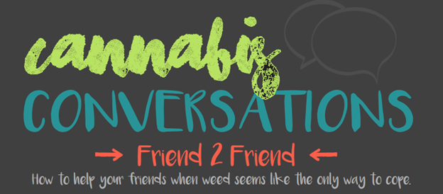
Contents
Title: Good Friends in Hard Times. Friendship: Own It. 3
List of Speakers 3
Note to Presenters 3
Introduction 4
Who Needs Help 6
How Can I Help 9
What to Say 11
What You Can Do 13
Take Care of Yourself 15
Who Can Help 18
Conclusion 20
Bonus Connection Activity: You Are Not Alone 21

Title: Good Friends in Hard Times. Friendship: Own It.
Workshop description: Being a friend to others is a day to day task, but do you know how to have the tough conversations? This workshop is about helping the people you care about cope during tough times without using substances and how to start difficult conversations with your peers.

List of Speakers
Introduction: ________________________________
Who Needs Help: ___________________________
How Can I Help: _____________________________
What to Say: _________________________________
What You Can Do: __________________________
Take Care of Yourself: ______________________
Who Can Help: ______________________________
Conclusion: __________________________________
(Bonus) Group Connection Activity:
_______________________ & _____________________.

Note to Presenters
This workshop follows the Cannabis Conversation Toolkit by Prevent Coalition in Clark County. Print out copies for audience members and instruct them to follow along as you progress through the script. Pictures of the toolkit are copied in the script for your reference.
This workshop is meant to be completed in approximately 45-50 minutes with a group of 15-30 youth ideally. In STASHA’s version, each presenter chose one topic to read and passed the script to the next person. This means there were eight youth presenters in total. Script can be adapted to however many presenters are interested and able to share.
Workshop materials included butcher paper, tape, markers, printed scripts, printed Cannabis Conversation toolkits (Link to toolkit: https://www.youthnow.me/youth-teens/friend2friend/), prizes and candy to pass out as an incentive for when people raised their hands and shared or answered questions, and lastly youth made flipchart presentation materials that outlined their main points/arguments for each section. This can be swapped out with a PowerPoint slide if that is easier. Contact Alaina.Green@clark.wa.gov for more information, clarification, further resources or support using the script. You are free to alter, adapt, remove, or add to this script as needed to match the desires and goals of your audience and community.
Thank you for your interest and partnership. -STASHA 2018.

Introduction
Raise your hand if one of your friends was going through something tough but you did not know how to start the conversation?
Raise your hand if one of your friends shared something they were going through and you just froze because you didn’t know what to say or what they needed or how to help?
Ok...so today we are going to help each other get through this...
But first let's get to know each other! Can everyone say their name, school, and favorite dessert? (OR if a large classroom- “Can everyone turn to the people next to them and introduce themselves with their name, school and favorite dessert?”)
The presenters here are members of _____________________ (program name). We are _________________ (insert program description here). !
This workshop, Good Friends in Hard Times. Friendship: Own it, is all about friendship, support and self-care. In the next 45 mins we will teach ways to help your peers cope, or deal with difficult stuff without using alcohol and other drugs.
One of the first ways to be confident in your self is by learning. This includes learning about yourself, your friends, and the community around you as well. This workshop is a way you can learn to help your peers while they are going through tough times. Everyone needs non-judgmental “Good Friends in Hard Times.”
Many of us hang out with our friends every day. Having deep conversations with even your closest friends can be scary. After this we hope you all come away with one new way to communicate and help a friend in your life that you care about!
We want to say thank you to Youth Now Initiative and Prevent Coalition for allowing us to share this toolkit, “Cannabis Conversations: Friend to Friend”, with you all. (Pass out the toolkit if you haven’t already) (Link to toolkit: https://www.youthnow.me/youth-teens/friend2friend/). They developed the toolkit with youth from all over Clark County and let us create this workshop with it. The toolkit is about supporting a friend who feels like cannabis is the only way to deal with stress.
We also want to thank the STASHA Peer Education program for allowing us a copy of this script to use and adapt freely as we are able.
This workshop is not going to be a workshop where we stand and talk at you....this is going to be a workshop were we teach each other and share ideas. We are all experts and we each have a lot of wisdom to share. We will be asking discussion questions and have time for us to all share ideas.
I am PUMPED to learn from you all. Get ready to share.

Who Needs Help
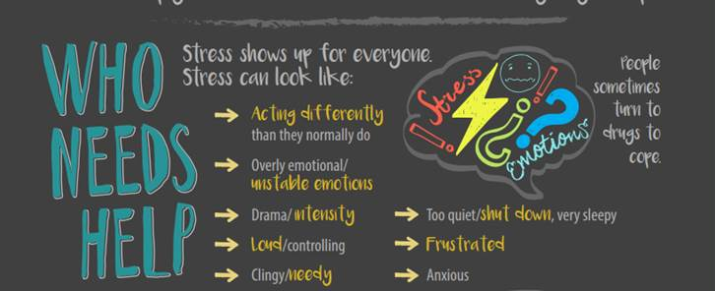
The first step in helping a friend is figuring out which friends needs help...right?
This can be more difficult than it sounds.
For a quick activity we want to trace a person on butcher paper. Can I get a volunteer who is willing to let us carefully trace you? We promise to respect your personal space. (Ask Volunteer, if no one volunteers than a STASHA member will)
Thanks for volunteering!
(Ask volunteer:) What is your name? What school do you go to? What’s your favorite flavor of jelly bean? (Then say:) We didn’t bring any jelly beans. We just wanted to learn more about you.
(Bring them up and trace them on butcher paper taped on the wall. Don’t trace them too closely- add personal space. Once done ask the same volunteer to spend 30 seconds drawing hair, a face and accessories).
Thanks, you can take a seat again now.
(Point to drawing) This drawing represents a person suffering from stress.
(Choose one question below, use rest as backup)
- What signs or symptoms appear in a person when they are stressed?
- What might it feel like, or look like in their bodies?
- How can you tell when someone you know looks stressed?

(Ask group to share ideas. As people are offering answers, write them on the corresponding parts of the traced person so there is a visual for people to map out where stress symptoms show up on a friend).
Example List:
- Not sleeping (label bags under eyes)
- Crying (label eyes)
- not showing up to school (circle the whole body as missing)
- tension or pain in their shoulders (label shoulders or neck)
- Neck feels tight (label neck)
- eyebrows are ruffled (label eyebrows)
- Eyes look tired (label face/eyes)
- Their brain having spiraled thoughts (point to brain)
- Heart is beating fast (label chest/heart region)
- Clenched fists (label hands)

The reason stress signals are important is because often times people who experience stress turn to alcohol or other drugs to cope with stress or to numb stress. Another reason is because sometimes people are stressed and we have no idea unless they tell us. It’s important to be able to identify when people around us need help.
We want you to learn how to help your friends cope with stress using healthy choices and to build what we call “Healthy Coping Skills.” If you and your friends learn healthy coping skills you can beat additional stressors that may come along with using drugs and alcohol, like addiction.
Fact! Did you know Marijuana is addictive? It’s harder to stop using marijuana if you start at a young age. Youth who start using marijuana, alcohol or other drugs — even occasionally — may be more likely to continue using later in life. We don’t want our friends to add more stressors to their lives, like getting in trouble with the law, losing college financial aid, in trouble with parents, addiction etc. so Let’s learn the signs of stress so we can identify when to reach out to a friend.
Most people are aware of these signs but every person exhibits signs differently. Some may be act differently, look anxious, appear tired or a variety of things. That doesn't mean that someone coping with stress will always show these signs. Even if they only show one of these signs it’s never bad to ask and make sure they're okay. But how might you approach them? It’s really important people feel confident asking their friends how they are doing. Nobody should feel alone when they are struggling.
Now that you’ve learned how to identify who needs help or might be stressed, let’s transition and talk about ways to make these people’s days a bit brighter.

How Can I Help
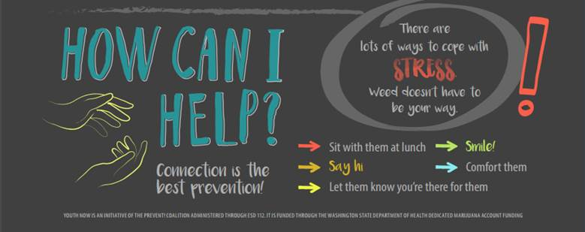
Let’s move along the toolkit to “How Can I Help?”
There are many ways we can support each other. In this section we’re going to dive into a few.
Generally speaking, the people who made this toolkit teach us “Connection is the best prevention.” What do you think this phrase means? (Wait for audience to raise hands).
Connection is feeling close to someone. Feeling important, valued, wanted. Kindness and inclusion are part of connection. All of these things, feeling connected, prevents people from unhealthy coping tools like using marijuana or drinking alcohol. When people feel connected to one another they are less likely to turn to things that might initially seem helpful but are actually harmful for them.
On the toolkit you’ll see some examples of ways to help people feel connected. Things like, sitting with them at lunch, saying hi and letting them know you're there for them. Another way is to smile to offer positivity. Even the little things can be more comforting than you think.
I personally love it when someone sends me a text message when they are not around just to let me know they are thinking of me. Can we all go ahead and pull out our cell phones really quickly and do that?
Everyone pull your phones out if you have one and choose someone to text. The text we will send is, “Hey, what’s up? Thinking of you. Hope you are doing well.” You can adapt it to your own words if you want!
(Write this text on the whiteboard for all to see and copy).
(Pose question): What is something little someone has done for you that made your day a tiny bit better, or even a lot better? What did this list on the toolkit forget to mention?
Let’s split into groups- of about three or four people and talk about a time when someone has done something for you that made a difference. You have two minutes.
(After two minutes) Alright, let’s come together again. Does anyone want to share something they heard or said?
Notice all the things we just brainstormed make us feel really warm, happy and fulfilled but don’t involve drugs or alcohol. We are capable of feeling better and happy without using harmful substances.
We’ve talked about what it looks like when people are stressed and a few different ways we might help them but how do we start the initial conversation? The next portion of the workshop will help you come up with ways to ask people how they are doing.

What to Say
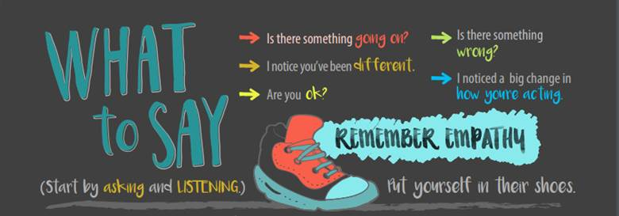
Now we are going to teach you how to talk to people when they are stressed and how to listen to people’s problems.
The toolkit says to start by asking and listening.
(Pose question): Why do people think this section emphasizes that listening is important? Does anybody have any reasons why listening is important during a stressful conversation?
Some reasons why listening is important are:
- Some people may not get attention at home from family or adults or they may receive negative attention when expressing themselves
- They are looking for someone to relate to
- By listening we can instill trust and create a positive relationship with that person
- Maybe they don’t need solutions or fixes to their problems, they just need to get it out of their head and VENT

When people truly listen to one another, connection (remember connection is prevention) can be made. Too often people just listen to respond. In this case, we don’t want to listen to respond- we want to listen to understand. When we start by listening with our full hearts and minds we can help understand what people are really going through and lift them up.
Before we start listening, we obviously need to get them to talk to us.
There are some examples on this toolkit for how to ask how people are doing. Is anyone willing to volunteer and read the examples out loud for us?
(Pose question): Feel free to write some of these down if they stand out to you- Does anyone have other ideas for what to say to someone who might need to talk? How have people approached you in the past to check up on you? Has anyone asked if you are okay in a really creative or kind way that stood out to you?
(if people don’t respond, call STASHA member names and ask them to give an examples. We want a big list).
(Pose question): Do you think the way people ask these questions changes or impacts the way you respond?
Thank you all for sharing- these are all really great examples.
The toolkit notes that we should remember empathy. Does anyone know what empathy means? Excellent, thank you for your definition. You’re right!
Definition: the ability to understand and share the feelings of another.
Use a bit of empathy when asking people how they are doing. If we are approaching people because we think they might be stressed or overwhelmed, we need to be understanding of how our words might impact them.
Real quick we want to try a roleplay. Role plays can be scary but they make a difference in our ability to feel confident and prepared when approaching our friends. Everyone, turn to a person next to you, choose one of the examples we brainstormed, listed on the toolkit or one completely new and ask your partner how they are doing. Remember empathy, listen to understand and hear their response. Be genuine. Give it your all even if it’s a stranger and it feels a bit awkward.
Tip! After the person responds to what is wrong I want you to practice validating how people are feeling. You can simply respond with…”That sounds like alot” or “That sounds hard.” Sometimes all we need is for someone to show us how we feel is ok.
Afterwards, switch and have your partner ask you how you are doing in a different way and then respond. You’ll just have about 1 minute to do this. Go!
Alright, times up! Thank you for practicing with us. Now that we are confident and equipped with how to ask people how they are doing, let’s learn step by step what we can do to support each other.

What You Can Do
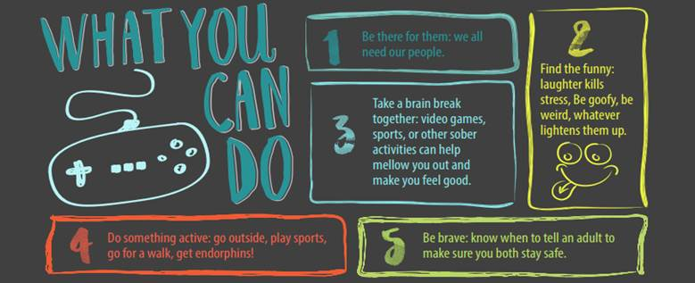
So you’ve covered who, how, and what to say. Now we’ve got five tips for you to keep in mind when helping people. Does anyone want to volunteer to read step one?
(Ask for volunteers to read each step, then read the “Respond with” the portion below out loud).
- Be there for them; we all need our people. (Respond with): For most of us it’s difficult to go through things alone or even sometimes unhealthy to cope when we are alone. We need to be there for each other.
- Find the funny…. (Respond with): has anyone ever been in a bad mood and their dad or friend comes in the room and tries to make you laugh? Usually for me I start smiling even though I tell them to stop and they are annoying but on the inside it actually does feel really good. When we smile, happy chemicals go to our brain and it makes things slightly better. Dad Jokes...Want to hear a joke about a piece of paper? Never mind… it’s tearable” What time did the man go to the dentist? Tooth hurt-y
- Take a brain break…(Respond with): Have you ever just wanted a distraction, but felt so stressed you needed someone to nicely encourage you?
- Do something active… (Respond with): For number 3 and 4, Doing something physical to keep your mind and body engaged can relieve stress, calm anxiety, and overall, help the both of you feel like the best version of yourself, without substances.
- Be brave. (Respond with): When is it important to reach out to a trusted adult when you are helping a friend? It can be scary to tell an adult your friend needs support, especially if your friend doesn’t want anybody knowing. Find a trustworthy adult to help you take action and help guide you in a direction that is safe.
If a friend or family member looks like they might be stressed take action while keeping these five steps in mind.
Now let’s break up into groups of 3 or 4. We’ll spend a couple minutes what are other ways to help a friend in a hard time or share a story of a time you have helped a friend through a hard time and how did you do it?
(Gives groups 2 or 3 minutes to discuss. Afterwards ask): “Alright let’s come back together now. Did anyone say something in their groups or hear someone else say something you’d like to share with the whole audience? What are ways to help friends?
Take 3-4 volunteer comments then move on.
We’ve discussed some ways to support friends, what stress looks like and who needs help and how to ask people what’s going on for them. It’s important to know how to establish boundaries while helping support your peers. This next team is going to talk about this topic.

Take Care of Yourself

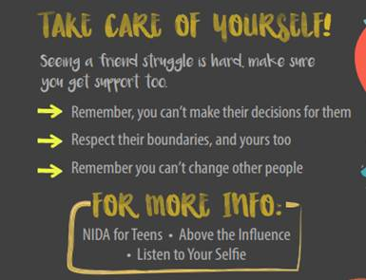
This section is about taking care of yourself by establishing clear boundaries.
How many of you have ever seen a friend or any other person struggle with anything? For those of you that have, have you noticed that as you try to help your friend it gets harder for yourself?
It’s difficult watching people we care about struggle. As we support them, we need to remember a few things:
- “Remember you can’t make decisions for them.” (Pose question): Have you ever had people make decisions for you- what does that feel like?
(Ask group to share ideas)

Example List:
- like I am not smart enough to figure it out on my own
- Controlling
- Overwhelming
- annoying

(After Brainstorm say) Even if we know what a person needs and we support them in getting it- they have the power to do something different. If we forget about our own needs it is possible to get overly invested in other people’s struggle. If we are too focused on the choices other people make, it can harm us too even though we’re just trying to help. Additionally, trying to make decisions for people can accidentally ruin the relationship with them.
Next on the toolkit is says, “Respect their boundaries, and yours too.”
(Pose question): what kind of boundaries do we establish in friendships, like what kinds of things do we consider going too far or crossing the line when helping a friend?”
Examples include:
  - Making decisions for other people,
  - Doing something for someone they don’t want or that pushes them away,
  - Going through their personal belongings
  - Going behind their back and talking to their parents or other friends

(After brainstorm say) We need to make sure we are respectful to people who are struggling when we support them. We can go out of our way to help them but we shouldn’t go out of their way to make positive changes for them. We can advise and support and be there for them but ultimately they need to make changes themselves and believe in wanting to change
Also, remember what kind of secrets you can keep or not keep. If someone is in danger of harming themselves or others or if someone has harmed them or they are in danger of being harmed. Remember that these are safety things that you can not keep and should reach out to a trusted adult.
- Next on the toolkit it says, “Remember you can’t change other people.” (Pose question):
  - Sometimes people aren’t ready to change quite yet, or perhaps they aren’t meant to change in this moment. Whatever the reason, we can’t let other people’s journeys put our own journeys to a halt.

One more thing about boundaries, but not mentioned on the tool kit is…
What about healthy boundaries for the helper? What healthy boundaries do you need when you help a friend to take care of yourself?
(Examples: Not available 24/7, need breaks, need someone to talk to to,
Excellent. We’ve mentioned a few times today that you need to get support for yourself as well. Our next speakers are going to share with you some resources you can reach out to.

Who Can Help
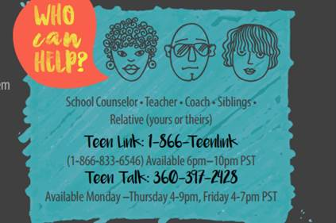
NOTE: Feel free to adapt these resources to ones available in your community.
The blue box titled Who Can Help is what we will be discussing next. This section provides resources that may assist you or your friend in any difficult situations you may face.
First shown are examples such as your school counselor, teacher, coach, siblings, or a relative of either person. Reach out to someone whom you feel comfortable talking to and asking for help from them.
If you are not comfortable with discussing such matters with those people, you may reach out to Teen Link or Teen Talk. Both numbers are provided in the box as well as the hours you may call. They are both in Washington and it is peer to peer support meaning you can talk to someone your own age and they are anonymous and confidential. You can read hours on toolkit.
(Pass out TeenTalk Business Cards)
These hotlines are useful for when you feel as though there is nowhere else to go or your support system just didn’t answer when you needed it. Raise your hand if that has ever happened to you.
Or if you need anonymous or confidential advice. Has anyone here ever called a hotline? Keep your hand up if you are willing to share what was it like?
I would like to call one together so we know what it is like, nothing is harder than picking up the phone….
We are going to first try calling…
“Your Life Your Voice - Boys Town Warmline” 1-800-448-3000​​)
“Kids, ​teens and young adults can call 24/7.they are there to talk if you're depressed, contemplating suicide, being physically or sexually abused, on the run, addicted, threatened by gang violence, fighting with a friend or parent, or if you are faced with an overwhelming challenge.”
(If they have a longer wait time, which happens, we are going to try the
Oregon Youth Line 877-968-8491
Teens are available to help daily from 4-10pm Pacific Time (adults are available by phone at all other times).
Trevor Project,866-488-7386.
Where trained counselors there available 24/7. If you are a young person in crisis, feeling suicidal, or in need of a safe and judgment-free place to talk, They are for youth who identify as LGBTQ
Like in real life if they don’t answer we would try other lines...there are sooooo many. We would have called our local line but they are not open 24/7, but they are the coolest.

(Call Line and say) Hi, I am with a group of friends and we were wondering if you had 1 minute to tell us about what is this warm line all about, like who can call?
Also, Can we call if we are worried about a friend?
Okay Thank you for your time! That was really helpful.
(end call) Raise your hand if you are like one ounce more likely to call if you need it? Or refering the numbers to a friend?
I suggest adding these numbers on the toolkit to your contacts on your phone incase you or a friend need them in the future. You can do that now if you want.

Conclusion
We are almost out of time so I’d like to briefly reflect on our workshop with you.
Our purpose was to inform you how to support you and your peers through difficult challenges using the Cannabis Conversations toolkit from Prevent Coalition. Today we heard about what (1) stress looks like and how it impacts your body, (2) different tips for supporting people who need help, (3) how to start the conversation and ask if someone needs extra support. (4) You learned some things you can do together to boost your mood and (5) you learned some things to keep in mind in terms of self-care and boundaries. (6) Lastly, you learned about hotlines and a few other resources for you or people you know to use when you feel you may need a little extra support.
(Pose question): Are there any important takeaways or favorite bits of information people are going to take with them or share with their friends? Or what are you going to Own from this workshop?
As you continue through your day I hope we’ve helped you feel confident and able to Own It, the theme of this conference. We hope you feel more able to own it, it being your ability and power in supporting your friends.
Real quick we’d like to thank Prevent Coalition again for allowing us to use their Cannabis Conversations toolkit, Connect Evergreen for partnering with us in putting together this summit and allowing us the space to teach this workshop and of course we want to thank you for your full participation and willingness to grow together.
If you like what you saw today, consider picking up an application to join our program, __________________, or find us online by searching _________________.
By being here today, you are showing that you care about other youth in your community. Your caring is an irreplaceable superpower that is so important to your community and your friends. Now you have been equipped with the tools to help and change the worlds of those around you.
Thank you and enjoy the rest of your day.

Bonus Connection Activity: You Are Not Alone
This activity can be instructed with most any size group; recommended 8-200 people.
Hello there. We are here to lead a powerful activity to help us digest lunch and get to know each other a little more. The activity we are leading is called “You Are Not Alone.” This activity will allow students to both acknowledge and address ways they are similar and unique from each other.

It is similar to “Cross the Line” or “Never Have I Ever” if you are familiar with those activities. If you are not...no worries we have directions!
It is important to begin “You Are Not Alone” by establishing common ground for the activity. We live in a diverse world. In this exercise we will explore the diversity among us, but also equally important realize how much we have in common and learn WE ARE NOT ALONE.
Directions: This activity if fairly simple. Can everyone stand and face the front? I will call out statements/categories/labels/descriptions, and ask that all of those to whom this applies to, Clap their hands in unison. (__Speaker Name___) will lead all the claps, even if the statement did not apply to them. For example, I might request that anyone with glasses please Clap their hands. If this describes you and you feel comfortable acknowledging it then you would Clap your Hands in unison with others it applies to. Once we clap, we will spend a couple of second in silence and each of us can think about how we feel, how loud or quiet the sounds of claps were, how you felt clapping or how you felt listening the clapping. After a few seconds, all of us who did not clap our hands will rub our hands together like this (demonstrate) to show unity and that we are here for support. Then I will continue with a new question.
At the conclusion of the activity, we will discuss what we felt and what we learned. There may be times when this activity makes you feel slightly uncomfortable. I would urge you to “Own It” and allow yourself to feel vulnerable since it may mean that you are about to gain an important learning or insight.
Ground Rules:
This activity might make people feel a bit uncomfortable or awkward, so there will be special group rules to help us feel more at ease. We want youth and adult to participate too.
There are a few important ground rules to this activity.
- Listen- This activity is a SILENT activity to allow everyone to experience the activity fully. This means no talking, giggling, nonverbal messages of judgement
- Respect - each person here deserves to be treated with dignity and respect at all times, and particularly during this activity.
- All that is shared should remain confidential. “Nothing that is offered should leave this room. However, if after the activity you really need to talk to a particular person, be sure to ask their permission first.”
- No Pressure- No one should feel under pressure to reveal anything about themselves that they don’t want to disclose. It is voluntary.

Questions:
Clap if... (Speaker Say these in a neutral tone all the way through as if none are good or bad, if people start talking in activity...which will happen gently remind them that this activity is most meaningful silent)
- This is a clap practice...Clap if you are at this workshop/meeting
- Clap if…. you are under the age of 18
- Clap if…. you are over the age of 18
- Clap if…. you have been to another country outside of the US
- you identify as female
- you identify as male
- You play a sport
- you can speak another language other than English
- you can speak 3 or more languages
- You have stayed up way too late reading a book
- You often feel overwhelmed with everything you have going on
- You identify as a leader
- You have been in love and been hurt
- You have caught yourself judging another person even before you met them
- You like Fruity Pebbles more than broccoli
- You have been bullied
- You have bullied another person
- You have been teased because of their religious background
- You have been teased about being a girl
- You have been teased or the target of a joke for the color of your skin
- You have a family member or you yourself have a disability that other cannot see
- You identify as male who has been told you shouldn’t cry, show your emotions or be afraid
- You have pressured someone to do something they didn’t want to do and felt sorry for it afterwards
- You routinely get your name mispronounced
- You have a favorite girls scout cookie
- You have screamed in a scary movie
- You sing in the shower
- You have laughed so hard you cried
- You have eaten food that fell on the floor
- You have had water or soda come out of your nose
- You have lived in a different state other than Washington or Oregon
- You have eaten a bug
- You have locked yourself out of your house or car
- You have or are being raised by a single parent
- You have personally witnessed or experienced a homophobic action or statement
- You feel you know very little about your cultural heritage
- You are an only child
- You are the oldest sibling in your family
- You are the youngest sibling in your family
- You sometimes have low self esteem
- You sometimes feel alone
- You have parents who are divorced
- You have a loved one... family, friend or you yourself identify as gay, lesbian, bisexual, transgender, LGBTQ+
- Someone in your family, or you yourself, has experienced the effects of alcohol or other drug dependence/addiction
- You are passionate about drug and alcohol prevention
- Someone you know has died by suicide
- You have worried about a loved one who is having thoughts of suicide
- You are passionate about suicide prevention
- You have reached out to a friend in a hard time
- You know a parent, teacher, older sibling, aunt/uncle, coach, pastor, activity leader or other adult you can talk to when you are in need
- After hearing these statements you want everyone here to know you are here for them
- You are willing to offer support to someone in this room if they need it
- You want everyone in this room to know they are not alone
- You feel less alone after participating in this activity, even if it is just a tiny bit

Now at your tables go through these questions as a group for about 3 min. After this if we have time we will ask groups to share some of their responses.
Reflection Questions:
- What kind of feelings did you have as you participated?
- What does this activity have to do with the theme of the Teens Care Too Summit, Owning it. Owning who you are?
Closing:
We are like an iceberg. From the outside people can only see about 10% of ourselves. The other 90% are things most do not know about us. These statements we read are not typical things we say when we introduce ourselves- they are things in the 90% below the waterline. We don’t share this stuff often...but we should. Sharing these things and being vulnerable allows other to feel less alone and to feel more connected to one another.
We hope you learned, no matter what happens in your lives, you are not alone. Even when you go through rough times, you may think you are by yourself, but in this activity we saw others are going through it too. We hope you learned to break walls down and be vulnerable and not feel bad about it because you are not alone.
Thank you for participating.

