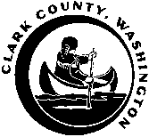

BOARD OF COUNTY COUNCILORS
Public Service Center, 1300 Franklin Street, 6th Floor
Vancouver, Washington

WEEKLY CALENDAR

Updated: 6/12/15

TUESDAY, JUNE 16, 2015

10:00 a.m. Board of County Councilors’ Hearing @ Board Hearing Room

4:30 p.m. Three-Year Anniversary of the Commission on Aging @ Board Hearing Room

WEDNESDAY, JUNE 17, 2015

8:00 a.m. Elected Officials Meeting @ Dragonfly Café

9:00 a.m. WS: Restoration Project Proposals @ Board Training Room

1:30 p.m. – Executive Session to discuss pending litigation with legal counsel; labor
2:30 p.m. negotiations @ Conference Room B

2:30 p.m. Board Time @ Conference Room B

